

Monday, 12/21/2020

**Bloomingdale Civic Association meeting**

Virtual meeting via Zoom during the public health emergency

BCA board members in attendance: Teri Janine Quinn, Jennifer McCann, Shery Howard, Robert Brannum, Paul Cerruti, Joe Levesque, Jake Parker, Scott Roberts, Bertha Holliday

38 people attended

The meeting commenced at 7:05 pm.

**Public safety**

Captain Stephen Keirn described the recent daytime shooting and then the nighttime shooting, which includes a vehicle is being examined by DC MPD Forensics. He listed a set of Assault with a Dangerous Weapon (ADW) crimes in the neighborhood. There was a 12/03/2020 PS5 robbery on the unit block of T St NW. He reported a significant increase in motor vehicle thefts on 1st St NW from Michigan Ave down to New York Ave NW from food delivery cars.

**Swearing in of BCA Corresponding Secretary and Representative to the DC Federation of Civic Association**

Ms. Quinn swore in Paul Cerruti, BCA Corresponding Secretary, and Robert Brannum, Representative to the DC Federation of Civic Associations.

**BCA Beautification Committee Chair announcement**

Ms. Quinn announced that David Do has volunteered to serve as the BCA Beautification Committee Chair. Mr. Do mentioned that $225 was raised on Giving Tuesday for the committee. He expressed excitement and solicited volunteers.

**Recognition of outgoing BCA board members**

Ms. Quinn acknowledged the services of outgoing board members Felicia Davis, Jean-Christophe Deverines, Ernie Emrich and Pat Mitchell. She thanked them for their work.

She provided brief comments on each person.

Ms. Howard described the plaque each outgoing board member received, which were hand-delivered in person today.

**BCA membership renewal**

Ms. Quinn said that Ms. McCann is reminding existing BCA members to renew their dues. She also invited residents who are not members to join.

**Year-end charitable contribution**

Ms. Quinn said that BCA would like to donate $500 to So Others Might Eat, located at 71 O Street NW in Truxton Circle. She described SOME’s services. She said that she met with the SOME program director Daryl Wright.

She said that Mr. Wright provided some guidance of how to address people on the street who are experiencing homelessness. SOME has reserved two $50 gift cards. BCA can retrieve the gift cards if you see someone in need.

A motion was made to support a $500 check to SOME. The motion was seconded. The vote results: 23 in support, 0 in opposition.

**Pepco power cable replacement project**

Pepco’s Travoris Culpepper shared a long presentation – replacing secondary underground power distribution cables.

Below are some slides from Pepco’s presentation:

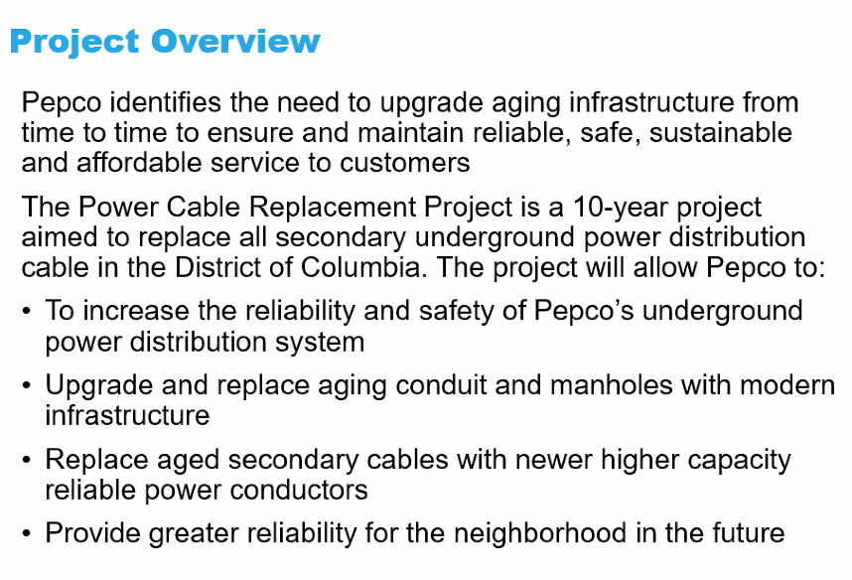

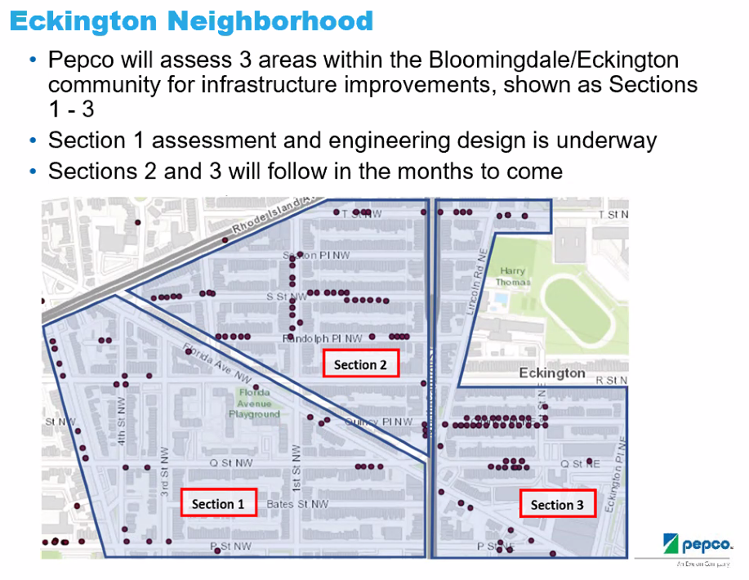

The dots on the map are manholes that need to be upgraded and enlarged.

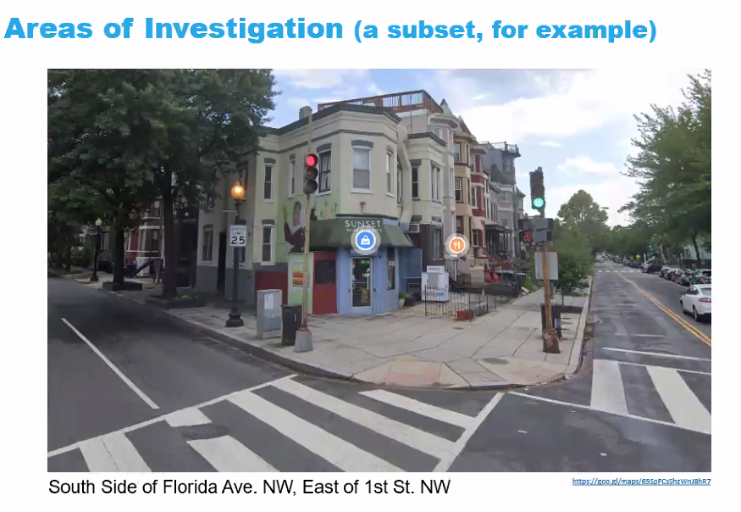

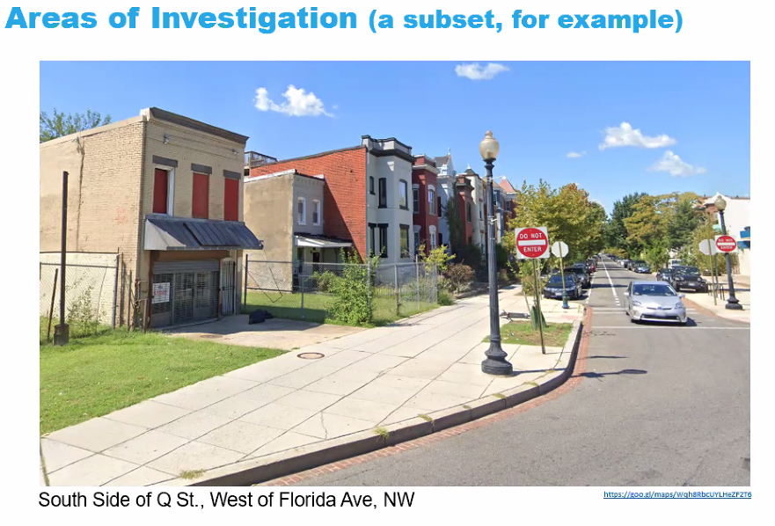

Now on the Pepco’s Tim Bugh

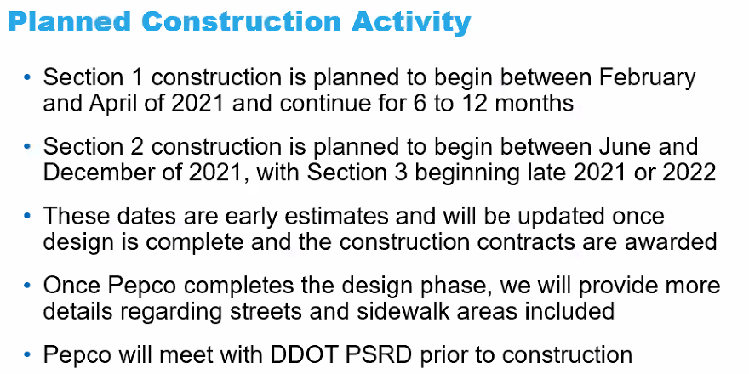

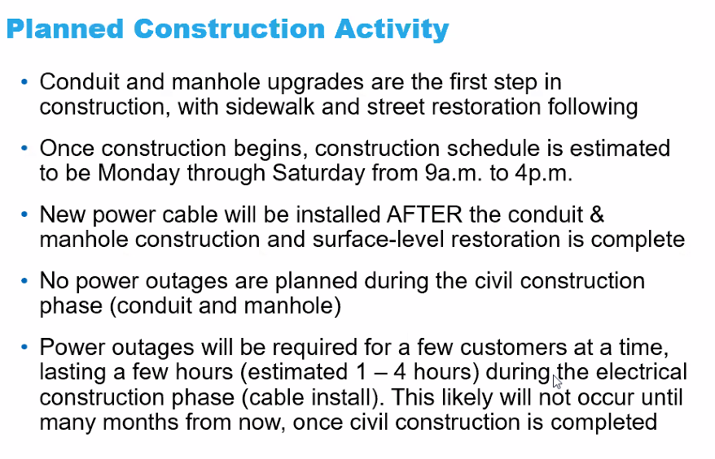

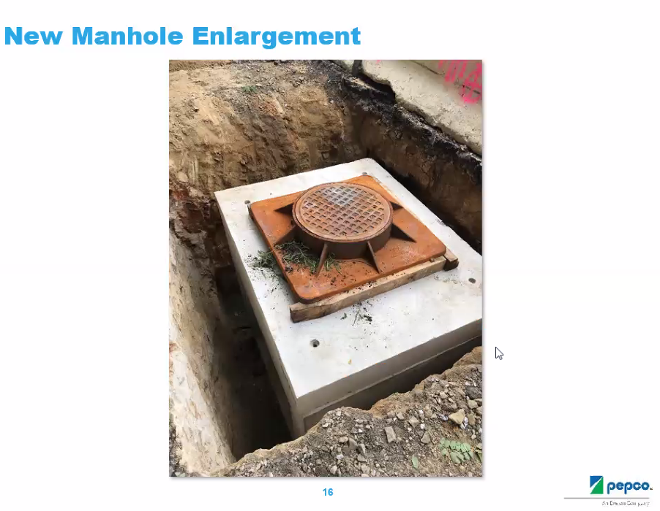

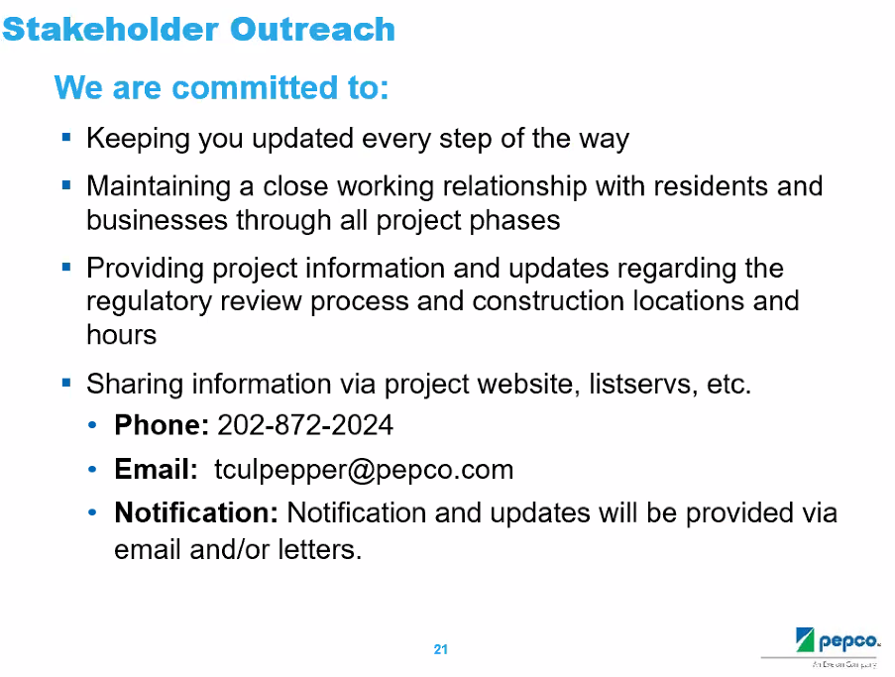

This Pepco plan was shared with DDOT back in July. It is being coordinated with other utilities, including DC Water.

There were questions about Pepco’s commitment regarding the public health emergency. Dr. Holliday would like to receive as much prior notification for work to be performed. She would like brick sidewalks to be replaced with brick sidewalks. She said that she would like non-brick sidewalks to be with brick sidewalks, if possible. Karla Lewis asked if there would notifications to impacted residents. Mr. Culpepper said that Pepco would use NextDoor, mail and Email.

This project has been implemented in Mount Pleasant and Adams Morgan.

Ms. Quinn would like contact information to be posted in the workzones.

Will the Pepco manhole covers be level with the street upon completion?

Ms. Quinn asked what Pepco’s transition program will be used to allow customers to catch up on their electric bills. Mr. Culpepper advised customers to contact Pepco customer support.

Mr. Culpepper’s cell phone: 202-680-3482.

**1st Street NW traffic calming**

Ms. Quinn said that DDOT has provided loose guidance on the placement of the planters at each intersection.

Mr. Levesque has been investigating obtaining soil for the planters.  The planters are only 18” inside at the top. He is hoping to be able to recruit nearby neighbors to water the planters.  He said that he has a tentative planter placement plan at the 1st St NW intersections. Ms. Quinn advised that ANC5E had no funds to share for this project.

This will be a Spring 2021 BCA Beautification Committee project.

Ms. Prentice expressed frustration that the planters will not provide an effective solution to 1st St NW traffic calming. Ms. Lewis said that the curb extensions are not working.

**2026 North Capitol St NW zoning special exception**

Ms. Quinn described the history of this case. Here is a link to the zoning case.

(<https://app.dcoz.dc.gov/CaseReport/CaseReportPage.aspx?case_id=20366>)

|  |  |
| --- | --- |
| **Case Number:** | 20366 |
| **Case Name::** | Colleen A Slattery, Trustee |
| **Case Summary:** | Application of Colleen A Slattery, Trustee, pursuant to 11 DCMR Subtitle X, Chapter 9, for a special exception under Subtitle E § 5201, from the lot occupancy requirements of Subtitle E § 304.1, to expand two existing rear balconies, on the second and third stories of an existing flat, in the RF-1 Zone, at premises 2026 North Capitol Street, NW (Square 3117, Lot 78). |
| **Relief Type:** | Special Exception |
| **Case Status:** | Active |
| **ANC:** | 5E08 |
| **Future Hearing Date(s):** | 01/27/2021 |

Mr. Brannum indicated that ANC5E decided to delay a vote until the BCA weighed in.

Mr. Levesque said that the developer constructed the rear decks inappropriately, but that the condo owner should not be held responsible for the developer’s errors. Mr. Brannum said that Ms. Slattery purchased the property knowing of the compliance issue.

Ms. Slattery advised that she has received letters from support from her abutting neighbors. She asked for support from the BCA.

Mr. Woods, Mr. Besserer and Ms. Brown expressed opposition to supporting the zoning special exception because it might serve as a precedent.

A motion was made to support the zoning special exception.

Text of the motion:

“The BCA reluctantly approves the special exception for 2026 North Capital St NW due to the extraordinary circumstances surrounding this case. We also note that this vote in no way sets a precedent for future BZA cases in Bloomingdale.”

The motion was seconded. The results of the vote: 10 in support, 5 in opposition.

**Community representatives**

Brittany Butler, a Ward 5 MOCR working with Nokomis Hunter, introduced herself. She provided updates from the mayor’s office, including the rollout of the vaccination, pandemic holiday protocol, Phase 2 adjustments and more.

Here is a subsequent Email from Ms. Butler, included below, on the topic of Covid-19 vaccine distribution:

**From:** "Butler, Brittany (EOM)" <[brittany.butler1@dc.gov](mailto:brittany.butler1@dc.gov)>  
**Date:** December 21, 2020 at 22:10:23 EST  
**To:** [bloomingdalecafinancesec@gmail.com](mailto:bloomingdalecafinancesec@gmail.com)  
**Cc:** tj quinn   
**Subject:** **Clarification on Covid 19 Vaccine Distribution for Week of December 21st**

﻿Good evening:

Thank you all again for including me in your community meeting tonight. As requested the total number of vaccine doses that will be distributed to Dc residents during the week of 12/21 are 34,350 doses; this is a combination of the Moderna and Pfizer vaccine.  Listed below is how much and where those doses are coming from.  To be  clear, the  vaccine doses coming from Operation Warp Speed are the doses given directly from the Federal Government.  The dosage amounts listed from VA and MD are gifted doses from our neighboring states; this is due in part because DC has a strong overlap of its workforce population coming from Maryland and Virginia.  I stand corrected on my earlier statements during the virtual meeting.  I hope this helps explain and clear up any confusion I may have caused.  Again I look forward to working with you alongside Nokomis to make Ward 5 a more enjoyable and livable area of DC.

Distribution week of 12/21

● 8,775 doses of Pfizer vaccine from VA (these doses were gifted from the State of VA to DC to distribute to its people)

● 4,975 doses of Pfizer from Operation Warp Speed (these doses were given from the Federal Government to DC to distribute to its people)

● 8,000 doses of Moderna from MD (these doses were gifted from the State of MD to DC to distribute to its people)

● 12,600 doses of Moderna from Operation Warp Speed (these doses were given from the Federal Government to DC to distribute to its people)

Thanks again for your time and patience.

Sincerely,

Brittany Butler

**Community Outreach and Services Specialist|Mayor’s Office of Community Relations and Services**

**Executive Office of Mayor Muriel Bowser**

**1350 Pennsylvania Avenue, NW,**

**Washington, DC 20004**

**202-394-4399**

**Preferred Pronouns: she/her/hers**

**Twitter and Instagram: @dcmocrs**



The meeting ended at 9:10 pm.

**Motion summary**

|  |  |  |
| --- | --- | --- |
| **Motion #** | **Motion** | **Results of motion** |
| 1 | A motion was made and seconded to support a $500 check to So Others Might Eat. The motion passed 23 in support and 0 in opposition. | Motion passed. |
| 2 | A motion was made and seconded to support the zoning special exception for 2026 North Capitol Street NW #2.    Text of the motion:  “The BCA reluctantly approves the special exception for 2026 North Capital St NW due to the extraordinary circumstances surrounding this case. We also note that this vote in no way sets a precedent for future BZA cases in Bloomingdale.”  The motion passed 10 in support and 5 in opposition. | Motion passed. |