Monday, 07/17/2023
Bloomingdale Civic Association meeting
Virtual meeting via Zoom

BCA board members present: Teri Janine Quinn, Jennifer McCann, Amy Oakes, Catherine Laidlaw, Sherry Howard, Eric Woods, Joe Levesque, Scott Roberts

The meeting commenced at 7:05 pm.

30 people attended.

Public safety
Metropolitan Police Department (MPD) Third District (3D) Lieutenant Jonathan Fleming provided an update on recent neighborhood crimes. He reported on the Stephon Lee arrest, who robbed the U First Market on Sunday, 07/02/2023. Mr. Lee was charged with Armed Robbery (Knife) of an Establishment.

BCA financial report
Ms. Howard reviewed the BCA 2nd quarter 2023 financial report

DC Department of Public Works (DPW)
Angela Prentice reported that DC Department of Public Works (DPW) has been regularly missing her block’s trash collection on the 2100 block of 1st St NW. Daniel Hayden mentioned missed collection on the 100 block of S St NW.

Celeste Duffie of DPW advised that these two blocks will be placed on a DPW supervisor’s list for monitoring.

Here are more comments from the Zoom chat:

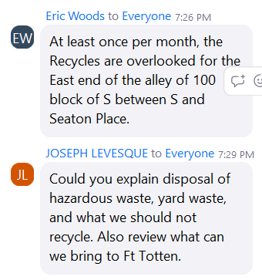

Ms. Duffie advised that the RFK stadium site is open for document shredding etc. Hazardous waste now goes to RFK. Information is on the DPW website: https://dpw.dc.gov/ .

A neighbor reported that the street cleaning machines cannot always sweep a street because vehicles have not moved from that side of the block.

Ms. Duffie directed residents to the DPW Zero Waste website for recycling information: https://zerowaste.dc.gov

She reported that the DC Office of Waste Diversion should be sending out a mailer soon for those households that are participating in the food composting pilot.

Ms. Quinn noted the earlier collection times during the hot summer months.

Ms. Duffie briefly described the DC DPW snow removal exemption for senior citizens and persons with disabilities. The exemption is not for snow removal, but for the time requirement for snow removal. Here is the link for more information: https://dpw.dc.gov/service/sidewalk-shoveling-exemption#:~:text=The%20Sidewalk%20Shoveling%20Exemption%20Program,for%20two%20consecutive%20snow%20seasons.

Ms. Duffie supplied her contact information:
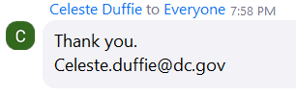

She also noted that DDOT contracts with a tree water service for newly planted tree box trees.

Community representatives
Ward 5 Mayor's Office of Community Relations and Services
Christopher Ingram, Ward 5 Mayor's Office of Community Relations and Services (MOCRS), provided assorted updates.

He shared his contact information:

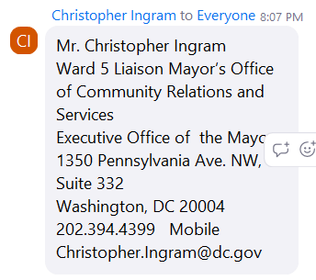

Ward 5 Councilmember Zachary Parker’s office
Sam Bonar, Constituent Services Coordinator/Scheduler, mentioned the DAP Project event scheduled at Creative Grounds this Thursday, 07/20/2023.

He shared his contact information:

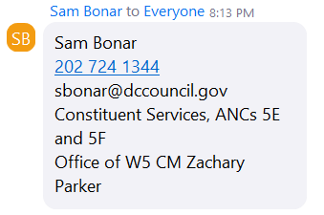

The meeting was then unfortunately Zoombombed.

The meeting was abruptly ended at 8:35 pm.

Motion summary

Motion # | Motion | Results of motion
 | No motions were introduced at this meeting. | Not applicable.

