Monday, 05/15/2023
Bloomingdale Civic Association meeting
Virtual meeting via Zoom

BCA board members in attendance: Teri Janine Quinn, Eric Woods, Jennifer McCann, Amy Oakes, Catherine Laidlaw, Bertha Holliday, Scott Roberts

22 people attended.

Ms. Quinn opened up the meeting.

Public safety
No one from the Metropolitan Police Department (MPD) Third District (3D) was present at the meeting. There was no crime report.

Community updates
Ms. Quinn provided info on this Saturday’s Bloomingdale Community Day in Crispus Attucks Park, 9am to 3pm.

Mr. Roberts advised about the Sunday, 05/21/2023, Bloomingdale Ecumenical Council choir concert fundraiser.

He also mentioned three zoning relief cases in Bloomingdale. Only two of the three zoning cases have been scheduled.

Community representatives
Sam Bonar, Ward 5 Constituent Services Coordinator/Scheduler, provided a summary of Ward 5 Councilmember Parker’s issues, including $11 million funding for the North Capitol study. Ms. Quinn & Dr. Holliday spoke about North Capitol deck-over project study. It was asked if some of the $11 million will be targeted towards the deck-over project. Dr. Holliday claimed that the councilmember has been disingenuous.

ANC5E05 Commissioner Kevin Rapp
He advised that traffic & public safety are key issues. ANC5E will be sending letters to the DC Department of Transportation (DDOT). A police walk is coming up. A block party in his single member district (SMD) is being planned for the Fall 2023. He mentioned that perhaps a dog trainer can be engaged to train dogs to catch rats.

ANC5E03 Commissioner Fred Carver
H reported that the DC Dept of Health is focusing on rats in Bloomingdale. He advised that 311 rat abatement requests are addressed quickly.

ANC5E05 Commissioner Huma Imtiaz
She would like 2nd Street NW crosswalks to get striped from Bryant St NW down to Rhode Island Ave NW. She said that vehicle drivers do not stop for pedestrians in the crosswalk areas. She will return next month.

ANC5E02 Commissioner Karla Lewis
On Friday, 04/21/2023, there was a neighborhood walkthrough with DC Department of Public Works (DPW) and CM Parker about the public trash containers. She mentioned that the ANC will review the 16 Quincy Pl NW zoning relief case which has a 07/26/2023 BZA hearing. She mentioned the DDOT Florida Ave NW/NE bus priority project meeting slated for Thursday, 05/25/2023.

She mentioned the three power outages on the unit block of R St NW in the past six months.

She said that a missing lamppost is being replaced on the unit block of R St NW.

So Others Might Eat (S.O.M.E.)
The invited S.O.M.E. guest Daryl Walker unfortunately needed to leave the meeting early. There was no SOME presentation.

BCA Scholarship
BCA Scholarship Committee Chair Jackie Duclos provided a report on the 2023 BCA Scholarship Awards program. She announced the two winners are Dominique Barksdale and Luca Lavoie. The two awards are for $1500.

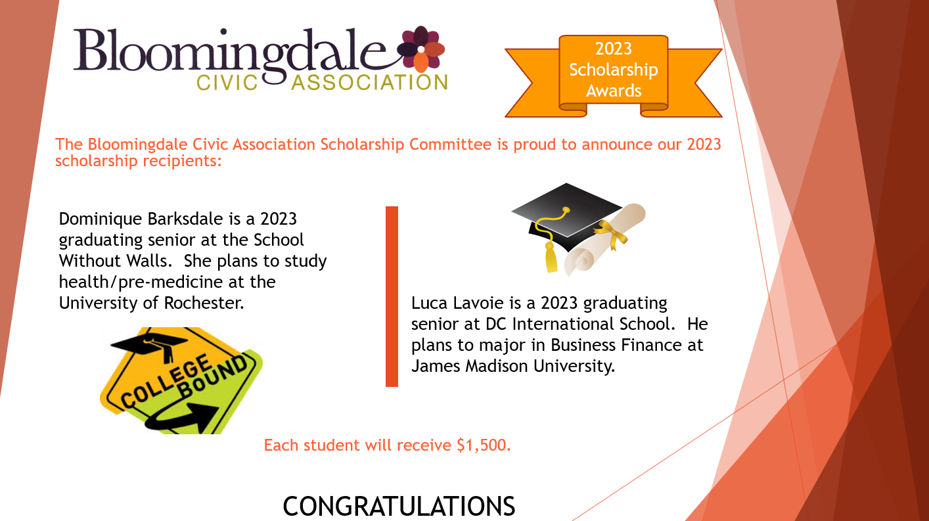

A motion was made and seconded to approve the two $1500 BCA scholarships. The vote passed 10 to 0.

She advised that the two scholarship awardees plan to attend the next BCA meeting.

The meeting ended at 8:38 pm.

Motion summary

Motion # | Motion | Results of motion
1 | A motion was made and seconded to approve the two $1500 2023 BCA scholarships for Dominique Barksdale and Luca Lavoie. | Motion passed.

