Monday, 04/24/2023
Bloomingdale Civic Association meeting
Virtual meeting via Zoom

BCA board members in attendance: Teri Janine Quinn, Eric Woods, Amy Oakes, Catherine Laidlaw, Bertha Holliday, Sherry Howard, Jennifer McCann, Joe Levesque, Scott Roberts

28 people attended.

Ms. Quinn opened the meeting and reviewed the meeting agenda.

Public safety
Metropolitan Police Department (MPD) Third District (3D) Lieutenant Jonathan Fleming provided a crime update, including the homicide of 16-year-old Mylaki Young on the 200 block of V St NW on Friday, 04/14/2023.

BCA financial report
Ms. Howard reviewed the April 2023 BCA financial report.

Bloomingdale Community Day at Crispus Attucks Park
Helena Okolicsanyi provided an overview of the Saturday, 05/20/2023, Bloomingdale Community Day event to be held in Crispus Attucks Park. She described the components of the yard sale, Taste of Bloomingdale and dog costume contest. This year, the event is partnering with the Humanity Rescue Alliance and District Dogs for donated blankets & towels. She advised that the event rain date is the next day on Sunday, 05/21/2023. She noted that the event may need to be postponed after the Memorial Day weekend.

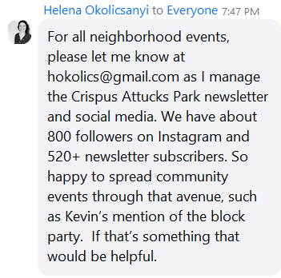

Ward 5 Councilmember Zachary Parker’s office
Ward 5 Constituent Services Coordinator/Scheduler for ANC5E & ANC5F Sam Bonar advised that the public safety plan has been released. He briefly described the DC Council legislation on reasonable controls on gun manufacturers, which is modeled after legislation in California.

He supplied his contact info:
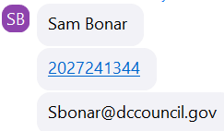

ANC5E commissioner reports
ANC5E05 Commissioner Kevin Rapp reported on rat issues. There will be a block party on Saturday, 06/03/2023, on Bryant & Channing St NW. He mentioned the recent letter from DC Delegate Eleanor Holmes Norton to the US Army Corp of Engineers about moving the perimeter fence back on the federal side of the McMillan site west of 1st St NW.

ANC5E02 Commissioner Karla Lewis described the process for requesting DC Department of Public Works (DPW) to return a removed public trash cans. She described her recent trash walks. ANC5E is seeking participants for its Zoning & Transportation Committees. She advised that ANC5E is being audited by the DC Auditors.

Ms. Quinn thanked the three ANC5E commissioners who contributed their ANC beautification funds for the Saturday, 04/22/2023, Bloomingdale Civic Association Beautification Day – Commissioners Lewis, Carver and Rapp.

BCA Scholarship Awards Program
Ms. Quinn reminded that the deadline for applications is this Friday, 04/28/2023.

Rat abatement
Ms. Quinn introduced Gerard Brown and Jan Jaminal of the DC Department of Health. Mr. Brown described the compost pilot program that just began this past Saturday, 04/22/2023.

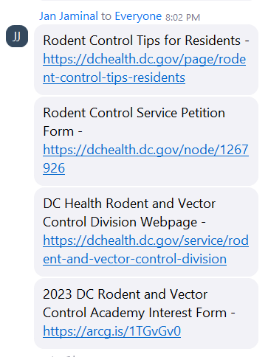
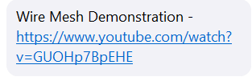
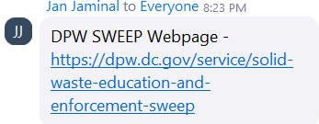
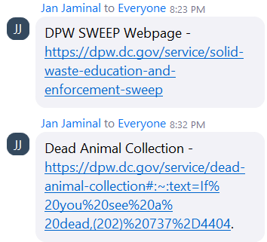

Ms. Quinn suggested that neighbors sign a petition to get an entire block rat abated.

Mr. Brown advised that trashcans should only be placed in the alley for next-day collection after 6 pm the night before. It was noted that neighbors should call 311 to remove dead rats from public space.

She thanked both Mr. Brown and Mr. Jaminal for their service.

Review of the BCA Beautification Day & Plant Giveaway event on Saturday, 04/22/2023
Ms. Quinn thanked BCA Beautification Committee Co-Chair Amelia Lofton and the entire BCA Beautification Committee. Mr. Levesque solicited volunteers to water & maintain the planters along 1st Street NW. Ms. Quinn thanks Big Bear Café for donating the coffee at the event.

Community policing survey
Mr. Woods reviewed the current community policing survey. He reported that there have been 111 responses to date. The survey ends this Sunday, 04/30/2023. He said that 98% of the survey respondents are Bloomingdale residents and 43% are BCA members. Mr. Woods will share the survey results once the survey period closes.

DC compost pilot program
Ms. Quinn suggested Googling for the most up-to-the-minute information on the compost pilot program.

DC Council oversight hearing on transportation
Ms. Quinn summarized her public testimony, including encouraging funding traffic calming programs in Bloomingdale and continued support for the North Capitol deck over project.

The meeting ended at 09:00 pm.

Motion summary

Motion # | Motion | Results of motion
 | There were no motions at this meeting. | N/A

