Monday, 03/27/2023
Bloomingdale Civic Association meeting
Virtual meeting via Zoom

BCA board members in attendance: Teri Janine Quinn, Jennifer McCann, Amy Oakes, Catherine Laidlaw, Bertha Holliday, Eric Woods, Scott Roberts

The meeting commenced at 7:10 pm.

35 people attended.

Metropolitan Police Department (MPD) Third District (3D) Lieutenant Jonathan Fleming provided a rundown of neighborhood crimes.

Government representatives
ANC5E04 Commissioner Huma Imtiaz announced a 10:00 am Saturday, March 25, 2023 rodent & vector control walkthrough starting at the Eleven Zero Seven business at 1st & Rhode Island Avenue NW.

ANC5E05 Commissioner Kevin Rapp advised that has been in contact with DC Congresswoman Eleanor Holmes Norton and others regarding the potential opening up of the federal side of McMillan west of 1st St NW. He mentioned the camera rebate program and requested sidewalk repairs. He also suggested a Bloomingdale sign along southbound North Capitol St NW.

ANC5E02 Commissioner Karla Lewis announced the Tuesday, March 21, 2023 ANC5E meeting. She mentioned the ANC resolution regarding the New York Avenue playground. She reported that the dancing endorsement has been removed from the Uncaged Mimosas liquor license renewal application.

Ward 5 Councilmember Zachary Parker’s Constituent Services Coordinator/Scheduler Sam Bonar provided a presentation on Ward 5 issues.

He provided his contact info:

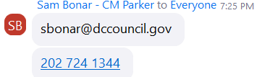

He said that the councilmember’s office is requesting new signage along 1st St NW near McMillan Avenue regarding restricting truck traffic. He mentioned the recent announcement of symbolic street designations legislation in Ward 5. He also discussed the DC Council budget oversight hearings: Ward5.us/oversight.

Mr. Bonar displayed a graph of vehicular crashes by ward. Ms. Quinn asked him why the number of crashes in Ward 3 was lower than in Ward 5.

Ms. Quinn said that the BCA would like to hear in advance about symbolic street designations in Bloomingdale.

DC Mayor's Office of Community Relations and Services (MOCRS) Ward 5 Anthony Black introduced himself. He provided his contact information:

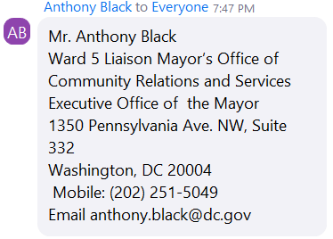

1733 1st Street NW HPRB
Traci Peitra introduced herself as the presentative for the renovation project at 1733 1st Street NW. She said that the DC Historic Preservation Office (HPO) advised the project needed to go before the DC Historic Preservation Review Board (HPRB).

The project will include a third-story rear addition. She presented a few slides from her HPRB application. She said that the height of the pop-up visible from the street has been reduced from 6 feet to 4 feet.

The case is on the agenda of the Tuesday, March 21, 2023, ANC5E meeting. It is on the Thursday, March 23, 2023, HPRB agenda. It was noted that the HPO staff report had not yet been issued.

A motion was made and seconded to support the HPO staff report. After discussion, the motion was withdrawn.

A motion was made and seconded to support the project if the pop-up roofline is not visible or minimally visible from across the street.

The vote was 8 in support, 5 in opposition, 1 abstention.

DC Health Rodent & Vector Control Division – rat abatement
The invited DC Department of Health representative was not present.

Mr. Levesque advised about the petition for Rodent Control Services: https://dchealth.dc.gov/sites/default/files/dc/sites/doh/publication/attachments/%28FINAL-FILLABLE%29%20Rodent%20Control%20Service%20%2803152022%29.pdf

BCA Beautification
BCA Beautification Committee Chair Amelia Lofton briefly discussed the BCA Beautification and Clean-Up Day on Saturday, 04/22/2023.

She said that Mr. Levesque will be assisting her. She said that plantings will occur in public space, including 1st & Rhode Island Ave NW. She solicited volunteers.

Ms. Quinn said that details for the Beautification Day will be shared at the Monday, April 17, 2023 BCA meeting. The BCA does not yet know the commitment for plant money from ANC5E.

Mr. Levesque described crepe myrtle infestation. He advised that dinotefuran insecticide can be used to control the crepe myrtle bark scale.

BCA Scholarship Committee
BCA Scholarship Committee Chair Jackie Duclos shared the link to the application form: https://docs.google.com/forms/d/e/1FAIpQLSdfutQbtXD43gk3CkWsAx53injpOxOy802pGnlNMaMxtOSMWw/viewform

She described the eligibility requirements for the scholarship awards program.

BCA Fundraising Committee
Ms. Quinn is seeking to provide $3000 for two scholarships. She said that there was an anonymous donor of $200 with an employer match of $200 at the last BCA meeting.

DC City Smokehouse is kindly sponsoring one scholarship for $1,500.

Ms. McCann and Ms. Oakes suggested selling BCA T-shirts at the Saturday May 20, 2023, Bloomingdale Community Day as well as at the Bloomingdale Farmers Market.

Here is the link to donate to the BCA: https://bloomingdalecivicassociation.org/donate/

Other
Ms. Quinn mentioned that some DCity Smokehouse patrons illegally park along Florida Avenue NW.

See this comment from St. George’s Episcopal Church’s Reverend Marilyn Jenkins:
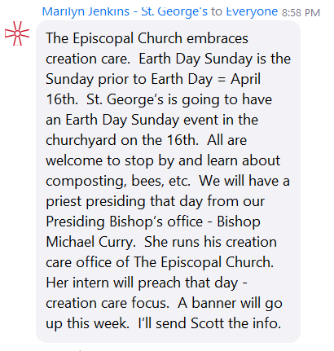

The meeting ended at 09:15 pm.

Motion summary

Motion # | Motion | Results of motion
1 | A motion was made and seconded to support the 1733 1st Street NW HPO staff report. The motion was withdrawn. | Motion withdrawn
2 | A motion was made and seconded to support the 1733 1st Street NW project if the pop-up roofline is not visible or minimally visible from across the street.  The motion passed 8 in support, 5 in opposition, 1 abstention. | Motion passes

