Monday, 01/23/2023
Bloomingdale Civic Association meeting
Virtual meeting via Zoom

BCA board members in attendance: Teri Janine Quinn, Eric Woods, Robert Brannum, Jennifer McCann, Robert Brannum, Bertha Holliday, Joe Levesque, Scott Roberts

The meeting commenced at 7:06 pm

33 people attended.

BCA President Quinn provided an introduction.

Public safety
Metropolitan Police Department (MPD) Third District (3D) Captain Chris Moore stated that there have been five stolen cars in the past month.

MPD is aware of minors trying to open unlocked car doors and breaking car windows. A big focus has been thefts from autos.

A neighbor asked about minors being arrested for misdemeanors and then immediately released.

Another neighbor reported that the issues with the unlicensed strip club at 209 Florida Ave NW have calmed down.

BCA Treasurer’s report
Ms. Quinn advised that the BCA Treasurer was unable to attend tonight’s BCA meeting. Therefore, there is no BCA treasurer’s report.

Community updates
Ms. Quinn introduced Sam Bonar, Ward 5 Constituent Services Coordinator/Scheduler for ANC5E and ANC5F. Here is the link to Ward 5 Councilmember Zachary Parker’s website: https://dccouncil.gov/council/ward-5-councilmember-zachary-parker/

Mr. Bonar provided his contact information.

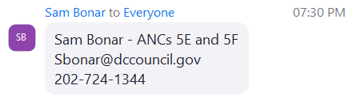

Ms. Quinn mentioned the upcoming DC Council oversight hearings.

Mr. Bonar provided a link to the oversight hearings schedule: https://docs.google.com/forms/d/e/1FAIpQLSdZQp558jxbnFDEOroAMUBJ6XWOIn3Nw7Vp5d_qZBpeyGO7bw/viewform

He advised about the Tuesday, 01/31/2023, Ward 5 open house at the Wilson Building.

Introduction of the Bloomingdale ANC5E single member district commissioners
Ms. Quinn thanked outgoing ANC5E08 Commissioner Robert Brannum for his service.

Ms. Quinn invited the four new ANC5E commissioners to introduce themselves – Karla Lewis, Fred Carver, Huma Imtiaz and Kevin Rapp.

ANC5E02 Commissioner Karla Lewis advised that she is a returning commissioner and was just elected as the new ANC5E chair.

Here is her contact information:

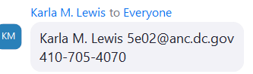

ANC5E03 Commissioner Fred Carver advised about the commission committees: ABRA (Alcoholic Beverage Regulation Administration) Committee, Zoning Committee and Transportation Committee.

Here is his contact information:

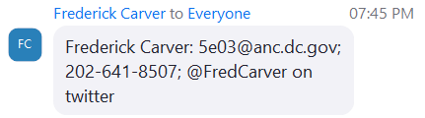

ANC5E04 Commissioner Huma Imtiaz said that she is working on rodent and infrastructure issues.

Here is her contact information:

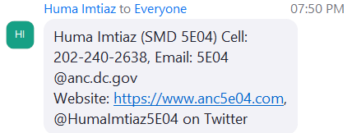

ANC5E005 Commissioner Kevin Rapp said that he has already met with representatives from the DC Department of Transportation (DDOT), DC Department of Public Works (DPW) and MPD

Here is his contact information:

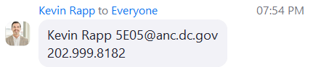

BCA Transportation Committee report
Bloomingdale residents Dana King and Greg Fuller introduced themselves as the co-chairs of the BCA Transportation Committee. They provided an overview presentation.

Here are a few slides of their presentation:

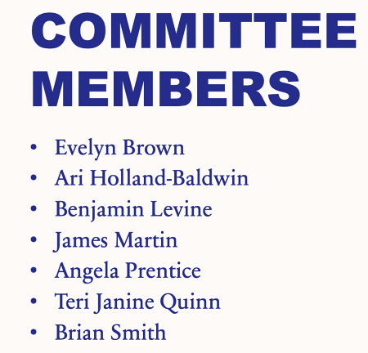

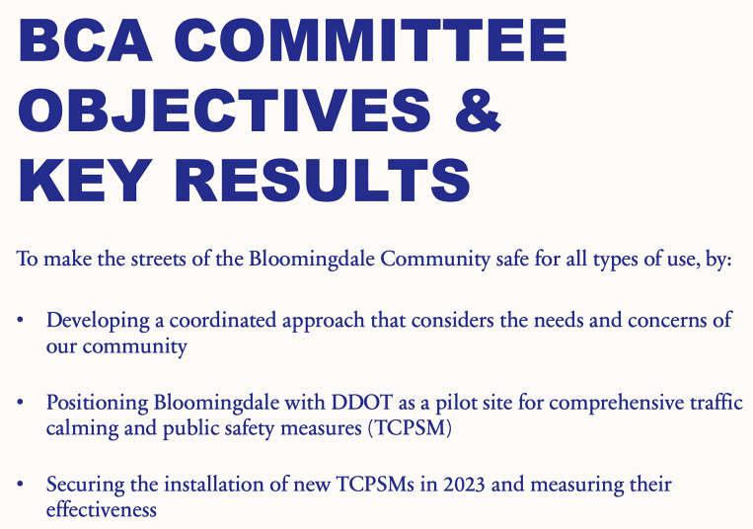

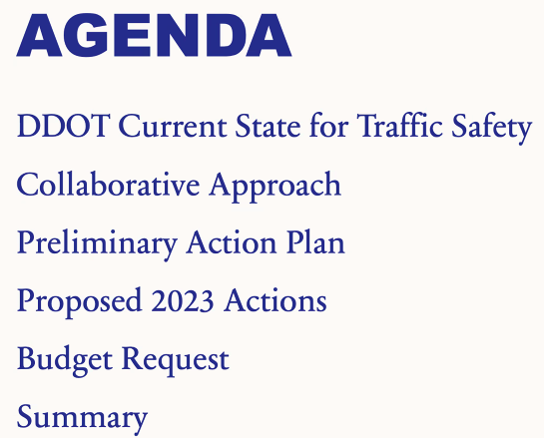

Ms. King and Mr. Fuller advised that there is a budget request for $500 from the BCA.

There was a motion to accept the BCA Transportation Committee Plan of Action (POA) and the $500 budget request. The motion was seconded.

The motion passed 15 to 0.

BCA Elections
Ms. Quinn turned over the meeting to the BCA Nominations Committee.

Mr. Brannum presented the slate of candidates. He offered that the slate be accepted.

- President – Teri Janine Quinn
- 1st Vice President - Bertha Holliday
- 2nd Vice President - Eric Woods
- Recording Secretary - Scott Roberts
- Assistant Recording Secretary - Amy Oakes
- Corresponding Secretary - Joe Levesque
- Assistant Corresponding Secretary - Catherine Laidlaw
- Financial Secretary - Jennifer McCann
- Treasurer - Sherry Howard
- Immediate Past President - Robert Brannum

- McMillan Advisory Group (MAG) Representatives: Joe Levesque, Brian Smith
- DC Federation of Civic Association Representatives: Robert Brannum, Felicia Davis
- DC Federation of Citizens Association:

15 people voted in support of the new slate.

McMillan Advisory Group (MAG) update
Mr. Levesque and MAG Chair Kirby Vining provided a brief update.

The meeting ended at 8:45 pm.

Motion summary

Motion # | Motion | Results of motion
1 | A motion was made and seconded to accept the BCA Transportation Committee Plan of Action (POA) and the $500 budget request  The motion passed 15 to 0. | Motion passes
2 | 15 BCA members voted to accept the slate of candidates. | There was no motion – just a vote of support.

