Monday, 01/22/2018
Bloomingdale Civic Association meeting
St. George’s Episcopal Church, 160 U Street NW

BCA board members present: Teri Janine Quinn, Serita Sanders, Angela Prentice, Sherry Howard, Scott Roberts

Approximately 70 people attended.

Ms. Quinn opened the meeting at 7:10 pm.

McMillan development project update

Kirby Vining provided an update on the McMillan project.

About one year ago, the DC Court of Appeals vacated the proposed development for the McMillan site on issues concerning the DC Comprehensive Plan, zoning, and historic preservation (the latter because the site has been a D.C. Historic District since 1991). The court also remanded several questions back to the District for consideration, generally asking
what justification there might be for why the District approved violations and other deviation from regulations that govern development on the site. Six days of hearings on those issues, before the Zoning Commission and the Mayor’s Agent for Historic Preservation, were held this past summer, but those two bodies have not yet issued orders formally concluding those hearings
on the remand issues. When those orders come out, they will be presented to the court for a final decision on the status of the development proposed for the site.

He advised that the next McMillan Advisory Group (MAG) meeting is Thursday, 02/08/2018, at Inspired Teaching Public Charter School, 200 Douglas Street NE, 7 pm.

BCA goal setting

Ms. Quinn then initiated a BCA Goal Setting session. She solicited volunteers to serve on the BCA board and to serve on BCA committees. She reviewed the BCA’s committees:

BCA Beautification Committee: to coordinate the annual Beautification Day in the springtime
BCA Scholarship Committee: to coordinate the BCA scholarship program
BCA Nominations Committee: to coordinate the BCA elections
BCA Fit & Fun Committee: to coordinate fun recreational activities in the community

Ms, Quinn stressed the need for volunteers for fundraising.

An attendee asked about senior services in our community. Ms. Quinn said that the BCA could invite the DC Office of Aging to a future BCA meeting.

Another attendee suggested an audit of public infrastructure issues, such as sidewalk issues. Ms. Quinn said that a DC government agency walkthrough can sometimes address systemic issues. She also referenced the Bloomingdale Village Square project. Volunteers could be used for soliciting funding for the BVS project.

Bloomingdale historic designation survey and subsequent vote

Ms. Quinn then initiated discussion of the Bloomingdale historic designation survey. She reviewed the history of the BCA survey vote. Owners of record should have received a BCA historic designation survey postcard in the mail. The final amount of survey postcard project is approximately $2100. The surveys were mailed using the DC tax records. Some neighbors have reported that they did not receive the survey postcards.

It was noted that the postcards must be postmarked by 01/25/2018. The results will be shared at the Monday, 02/26/2018, BCA meeting. The results will provide info to these three questions:

- How many postcards were received?
- How many postcards marked the yes box?
- How many postcards marked the no box?

Ms. Quinn reviewed the rules for voting at a BCA meeting. If you are a member today, you can vote at any meeting throughout this year.

Ms. Quinn said that DC Historic Preservation Office (HPO) will send a 45-day notice prior to the HPRB hearing date.

Ms. Quinn explained the BCA will take a vote on historic district designation. She said that ANC5E traditionally has voted in step with the civic associations. She said that neighbors are welcome to reach out to their ANC5E single member district (SMD) commissioners. She said that neighbors can write to the HPO/HPRB and can also appear in person at the HPRB hearing,

She said if the BCA votes in a different way than the results of the BCA survey vote results, then both can be shared.

She said that the language of the vote motion would not be discussed tonight. She explained that it would be better to do so with the results of the survey results in hand.

A meeting attendee asked if the BCA vote would occur at the Feb 2018 meeting. She said the she expects that the BCA vote would be at the March 2018 BCA meeting. Anyone wishing to vote at the March 2018 BCA meeting would need to become a BCA member by the February 2018 BCA meeting.

Ms. Quinn suggested flyering the entire neighborhood to advise about the BCA March 2018 historic designation vote. She said that 3107 names were used for the BCA survey postcard mailing.

There was much discussion about how to best flyer the neighborhood. An attendee suggesting using NextDoor. Someone suggested using CSOSA volunteers that requires a few weeks leadtime.

There was active discussion about the language to be used a potential flyer. Ms. Quinn said the flyer would include details about the BCA meeting where historic designation vote would occur.

Ms. Quinn reported that the current BCA survey postcard bill to date is $2017.47.

The following meeting attendees volunteered to craft text for the flyers and present ideas for the mechanics of flyering:

- Amy Studdert
- Jean-Christophe Deverines
- Jennifer McCann

The flyering of the entire community would occur before the February 2018 BCA meeting. The flyering volunteers would present their suggested flyer text to the BCA board members prior to the February 2018 meeting.

Motion: Nick Sementelli offered a motion that the BCA commit to flyering the neighborhood prior to the February 2018 BCA meeting. The motion passed 20 to 6.

The BCA board will approve the flyer costs with the expectation that it the cost would be below $200.

Public safety update

PSA 501 Sergeant Fawzi advised about newly promoted PSA 501 Lieutenant Peter Frenzel.

Sgt. Fawzi said that package theft continues. A neighbor reported a theft of treebox fences and plants.

150 S Street NW

Ms. Quinn provided a brief update on the development plans for the Eritrean Church building at 2nd & S St NW. She noted that the historic landmark nomination has been filed to preserve the original church building. The property owner was required to turn in the issued raze permit.

BCA treasurer’s report

Ms. Howard provided a financial report:

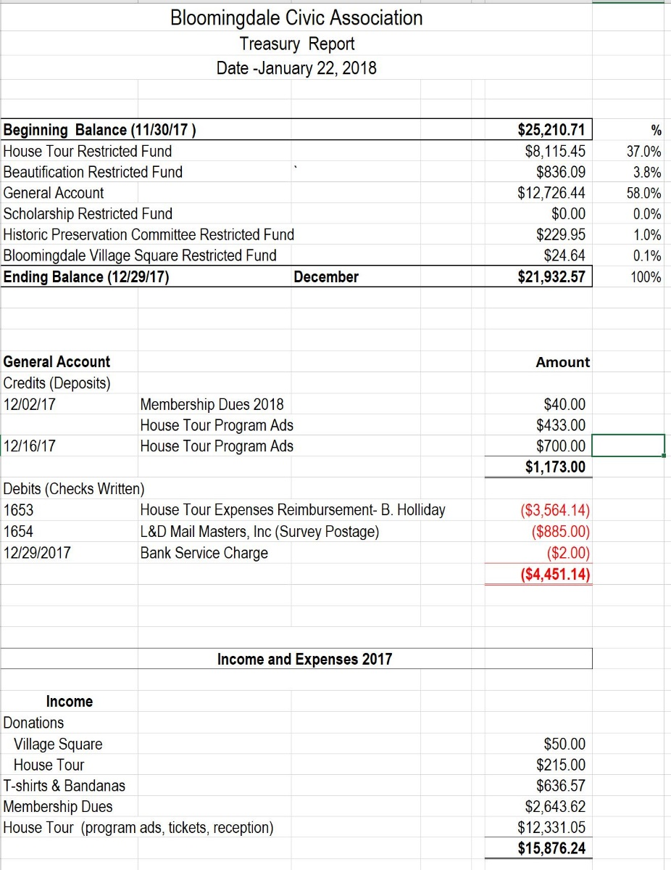

She advised that the BCA house tour raised more money that was spent. Ms. Quinn said that there is no money for the 2019 BCA house tour.

Community representatives and presentations

Cyril Crocker of Ward 5 CM McDuffie’s office distributed the Ward 5 2017 summary report. Ms. Quinn asked about DC Water addressing insurance claims from the First Street Tunnel project. Mr. Crocker said that DC Water is stonewalling by deferring claimants directly to DC Water’s insurance company.

The meeting ended at 8:55 pm.

Motion summary

Motion # | Motion | Results of motion
1 | Nick Sementelli offered a motion that the BCA commit to flyering the neighborhood prior to the February 2018 BCA meeting. The motion passed 20 to 6. | Passed

