BCA House Tour Design Workshop Series 2017

The Bloomingdale House Tour Workshops have quickly become a distinguishing and popular element of the Tour. The Workshops are 45 minutes in length (including a 15-minute Q &), and focus on topics ranging from architectural history and contemporary neighborhood urban design, to color, pattern, lighting, wallpaper and landscaping. All workshops are presented by experienced architects and designers who reside in Bloomingdale and are excited to share their diverse unique visions of design.

Presented by: Ahmet Kilic
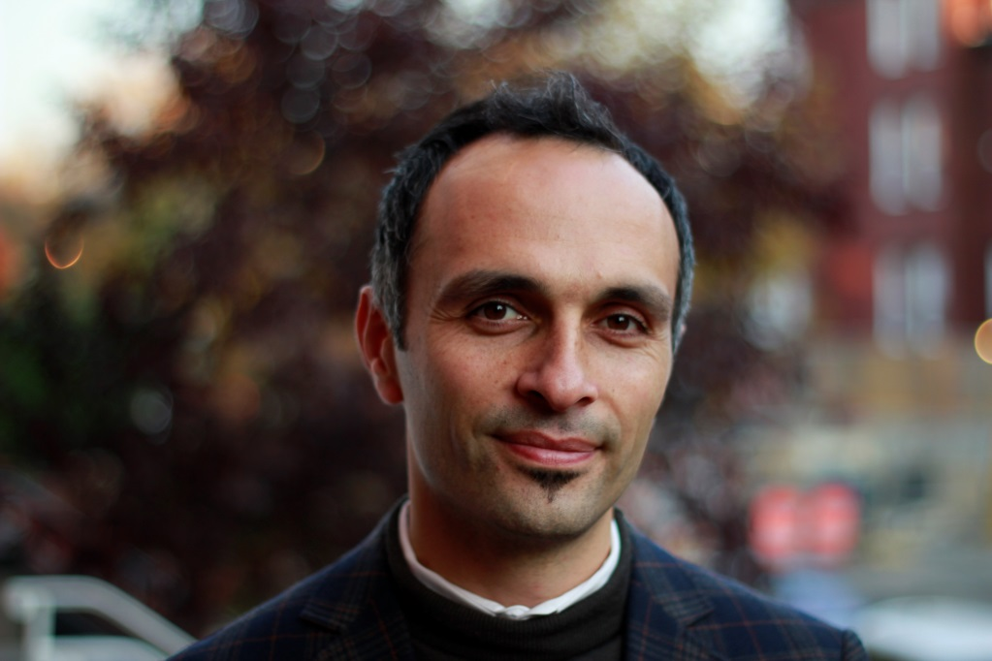

TOWNHOUSES THEN AND NOW
Workshop Description
The District of Columbia city grid was laid out at the end of 19th century. Bloomingdale, the neighborhood in which I live and work, reached its complete build out more than 100 years ago, at the beginning of 20th century, and hasn’t changed much since then from the urban design stand point. The townhouse blocks that were laid out much earlier than the invention of the automobile are still one of the most popular residential products in the market.
Participating on townhouse addition projects as an architect, I have been amazed to see the clues of the lifestyle at the turn of the century. My amazement further continues observing how these homes adapt to the contemporary lifestyle.
If the building is well preserved, the meticulous workmanship and the aesthetics of the era often prevent the house from being demolished for alterations. In this scenario, the contemporary functions find their way into the existing layout. Some functions become obsolete and a new function finds its way into the very same room. If the building interiors are seriously damaged, then the contemporary program governs to create its own layout.
The front façade of the townhouses on the other hand is much more resistive to change, partly because of the durability of the materials and partly because of the challenge of designing a façade that would better fit into the block.
This all makes someone think about what is timeless what is transient in architecture.

Bio:
Ahmet, is a Registered Architect in the District of Colombia, Virginia and Maryland with more than 16 years of experience in the architectural and planning field. He is a member of American Institute of Architects, a LEED Accredited Professional and a member of Turkish Chamber of Architects. Ahmet was graduated in 1998 from METU, the top-ranking architecture school in Turkey, with a Bachelor of Architecture with a minor in Structural Engineering. He also has completed the Master of Architecture program at the same university in 2001. Subsequently, an architectural design firm in United States recruited him. He has worked at large size architectural firms for several years where he used his design and management skills working on variety of projects in US and overseas. His experience covers mixed-use design to unit interiors; high-rise towers to townhouse neighborhoods; big box retail to small coffee shops. In 2010 he founded his own firm, Urbane Architects, where he specializes in residential, commercial and institutional projects.

Presented by: M. Jennifer Harty, AIA, LEED (AP)

BLOOMINGDALE - ENVISIONING OUR GREATEST POTENTIAL THROUGH URBAN DESIGN
Workshop Description:
Please join M. Jennifer Harty, AIA, in exploring the Bloomingdale streetscape, unlocking its hidden potential to rival the best of urban neighborhoods across the globe. This seminar will be taking stock of our current architectural, landscape, and urban assets, and question how they may be appropriated to achieve our greatest future self. We will learn about the latest in urban design strategies, from lighting and street furniture, to landscapes that increase storm water retention. We will also investigate the effectiveness of public art, discovering how simple ideas can create a sense of place for our community. Finally, we will discuss what tools are at our disposal to make these visions into reality. A 15 minute Q&A will follow the seminar.

Bio:
M. Jennifer Harty, AIA, is a Registered Architect, a member of the American Institute of Architects and the US Green Building Council (LEED AP). She has practiced commercial and residential architecture in the District for 10 years. Before founding HxH Architects, Jennifer apprenticed at Rafael Vinoly Architects. She was also a Project Architect at Cunningham Quill Architects, and an Associate at Beyer Blinder Belle Architects. Jennifer holds a Bachelor of Arts from Columbia University, and a Masters in Architecture from Harvard University.

Presented by: Molly Scott
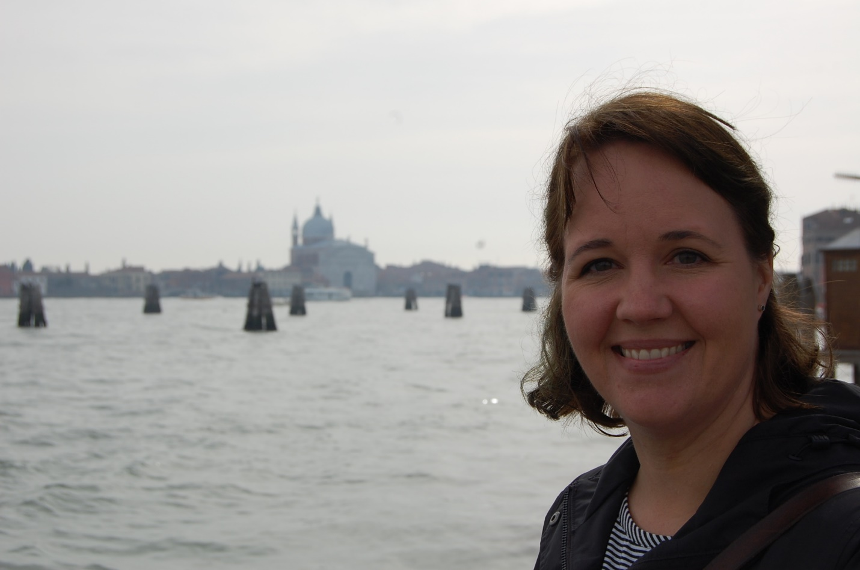

LANDSCAPE DESIGN FOR SMALL SPACES
Workshop Descriptions:
Presents basic design principals and suggestions for getting the most out of our small Bloomingdale gardens, plus recommended plants that do well in our climate.

CONTAINER GARDENING AT ITS BEST
Outlines ways to enhance garden spaces with planted containers for color in different seasons, as well as some discussion of vegetable container gardening.

Bio:
Molly Scott, Registered Landscape Architect, MD/VA. Principal/Owner at Molly Scott Exteriors, LLC
Molly has been gardening since early childhood. Her appreciation for nature was fostered as a kid growing up exploring the native woodlands in Southeastern Pennsylvania, and enjoying the rich horticultural resources in the Brandywine Valley. Molly moved to DC in 1999, living first in Adams Morgan and moving to Bloomingdale in 2006.
Since 2011, Molly has run her boutique landscape design business, Molly Scott Exteriors, out of her home in Bloomingdale. Her previous work experience in the industry includes 11 years as a landscape designer/salesperson at a local high end landscape design/build firm. Molly is a member of the American Society of Landscape Architects (ASLA) and the Association of Professional Landscape Designers (APLD) and has been the recipient of numerous awards from the Landscape Contractor’s Association (LCA) of Maryland/DC/Virginia.
In the rare times when she's not working she loves volunteering with Bloomingdale’s “Hidden Gem”, Crispus Attucks Park, gardening, reading, cooking, and exploring DC.

Presented by: Tynesia Hand-Smith

COOL SPACES HOT WALLCOVERINGS
Workshop Description
Not your grandma's wallpaper that's for sure! There was a time when wallpaper was popular, then it wasn't....at all. A whole generation ran from it and only touched it when they had to spend hours removing it.
In the famous words of LL Cool J "Don't call it a come back, I've been here before..." Wallpaper has triumphantly emerged from the exile of naysayers.
This discussion will introduce wallpaper as a viable design solution for walls, ceilings and furniture.

Bio:
Tynesia is the principal designer for Design 36ixty Interiors, a DC based boutique design firm crafting solutions for both residential and commercial clients in the metro area. Tynesia has over 17 years of experience and a proven track record that includes D.C. hot spot Smith Commons, appearances on TLC and the Discovery Channel, and several Model Home awards for Best Interiors.
A native New Yorker from Brooklyn, Tynesia credits her eclectic style to growing up in the city. Tynesia is a Howard University graduate and holds a Bachelor's Degree in Architecture.
She enjoys spending time with friends and her favorite pooch -- Lucy Lu.

Presented by: Zach Sherif
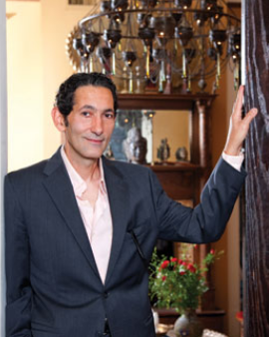

UTILIZING LIGHT, COLOR AND TEXTURE TO ENTERTAIN THE EYE, STIMULATE THE SENSES, & SOOTH THE SOUL
Workshop Description:
This workshop will explore color, pattern and light, and how they can dance in harmony to create a recital worthy of a standing ovation.
The presenter –—will explore the essentials of utilizing light, color and texture to create unique spaces that delight, comfort and inspire. Mr. Sherif will outline the industry's ‘musts’ to create a well-balanced aesthetic and thoughtfully articulated interior.
The idea of using color and pattern often causes one to step back and retreat behind a veil of what is common, ordinary and oftentimes beige. Understanding how to mix and match colors and patterns can greatly increase the success of a design scheme and the vibrancy of the space.

Bio:
Egyptian by birth, Zach Sherif received his BA in History in Art History with a minor in Architecture/Sociology from the American University in Cairo. He then attended a two-year Senior Seminar Program at The New School’s Parsons School of Design (New York City), focusing on the interface between studio arts and sociology.
Mr. Sherif’s accomplishments involve an array of design, creative director, arts production, and arts editor and curator activities. But he is most known as a Washington DC-based internationally renowned lighting and interior designer. His signature style is defined by his one of a kind chandeliers and his flair for the eclectic. Mr. Sherif’'s work has been featured for decades in all of the leading international and domestic design publications, and most recently on the cover of Elle Decor (August 2017).

